## Normalization

* + 1. Using the INVOICE table structure shown in the table, draw its dependency diagram and identify all dependencies (including all partial and transitive dependencies). You can assume that the table does not contain repeating groups and that any invoice number may reference more than one product. You can also assume that any given product is supplied by a single vendor, but a vendor can supply many products. Therefore, it is proper to conclude that the following dependency exists:

PROD_NUM → PROD_DESCRIPTION, PROD_PRICE, VEND_CODE, VEND_NAME

(*Hint*: This table uses a composite primary key.)

Table 1 Sample INVOICE Records

|  |  |  |  |  |  |
| --- | --- | --- | --- | --- | --- |
| **Attribute Name** | **Sample Value** | **Sample Value** | **Sample Value** | **Sample Value** | **Sample Value** |
| INV_NUM | 211347 | 211347 | 211347 | 211348 | 211349 |
| PROD_NUM | AA-E3422QW | QD-300932X | RU-995748G | AA-E3422QW | GH-778345P |
| SALE_DATE | 15-Jan-2004 | 15-Jan-2004 | 15-Jan-2004 | 15-Jan-2004 | 16-Jan-2004 |
| PROD_LABEL | Rotary sander | 0.25-in. drill bit | Band saw | Rotary sander | Power drill |
| VEND_CODE | 211 | 211 | 309 | 211 | 157 |
| VEND_NAME | NeverFail, Inc. | NeverFail, Inc. | BeGood, Inc. | NeverFail, Inc. | ToughGo, Inc. |
| QUANT_SOLD | 1 | 8 | 1 | 2 | 1 |
| PROD_PRICE | $49.95 | $3.45 | $39.99 | $49.95 | $87.75 |

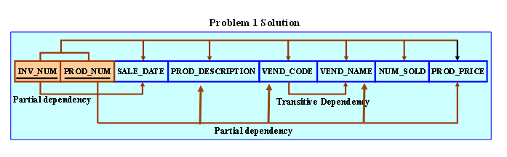

* + 1. Using the initial dependency diagram drawn in Problem 1, remove all partial dependencies, draw the new dependency diagrams, and identify the normal forms for each table structure you created.

(*Hint*: Your actions should produce three dependency diagrams.)

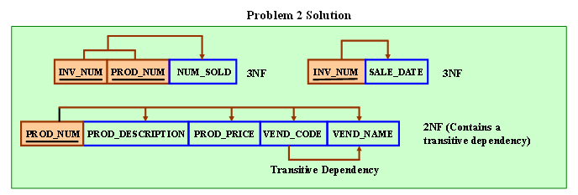

* + 1. Using the table structures you created in Problem 2, remove all transitive dependencies, draw the new dependency diagrams, and identify the normal forms for each table structure you created.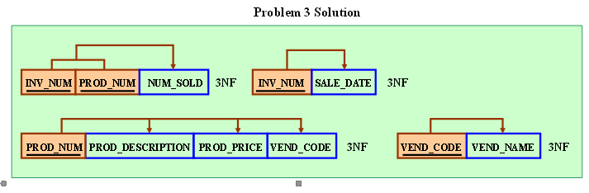

4. Dream Sdn Bhd is a tour agency is using traditional file-based system to manage and maintain all records of their customers’ bookings. TourPackages Table shown below is an example of data file stored in their system.

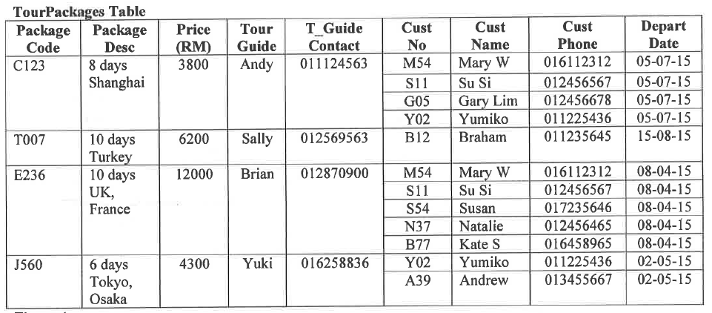

(a) Based on the sample data given in the table, discuss each of the following data anomalies with a specific example:

* Insertion anomaly
* Modification anomaly
* Deletion anomaly

(b) Normalize the table given below to a set of third normal form (3NF) relations using DBDL format.

|  |
| --- |
|  |
|  |

Normal Form

5. Lovely Pet Clinic stores health history records of its customers’ pets as shown in the table below:

## 

(a) Based on the sample data above, explain the meaning of functional dependency.

(b) Based on the sample data given in the table, discuss each of the following data anomalies with a specific example:

* Insertion anomaly
* Modification anomaly
* Deletion anomaly

(c) Normalize the table given below to a set of third normal form (3NF) relations using DBDL format.

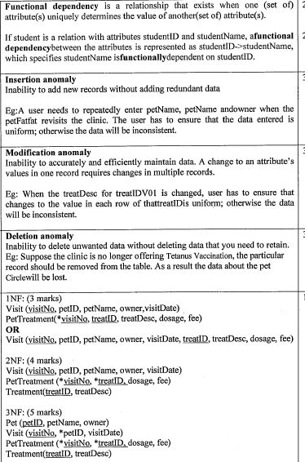

6.The table shown below contains facts about patients, health care providers, patients’ visits to a clinic, and diagnoses made by health care providers.

|  |  |  |  |  |  |  |  |  |
| --- | --- | --- | --- | --- | --- | --- | --- | --- |
| **VisitNo** | **VisitDate** | **PatNo** | **PatAge** | **PatCity** | **PatZip** | **ProvNo** | **ProvSpecialty** | **Diagnosis** |
| V20030 | 13/1/2005 | P1 | 35 | Lahat | 31600 | D1 | Internist | Ear Infection |
| V20030 | 13/1/2005 | P1 | 35 | Lahat | 31600 | D2 | Nurse Practioner | Influenza |
| V82020 | 20/1/2005 | P3 | 20 | Tronoh | 32200 | D2 | Nurse Practioner | Pregnancy |
| V73220 | 18/1/2005 | P2 | 62 | Taiping | 34500 | D3 | Cardiologist | Murmur |

Normalize the table into a set of 3NF relations using DBDL format. Hint: The zip code of the patient can be used to determine the city.

|  |
| --- |
| **1NF**  **Patient Visit** (VisitNo, VisitDate,PatNo, PatAge, PatCity, Patzip)  **Patient Diagnosis** (VisitNo, ProvNo, ProvSpecialty, Diagnosis)  **2NF**  **Patient Visit** (VisitNo, VisitDate,PatNo, PatAge, PatCity, Patzip)  **Patient Diagnosis** (VistitNo, *ProvNo, Diagnosis)  **Provider** (ProvNo, ProvSpecialty)  **3NF**  **Patient** (PatNo, PatAge, *PatZip)  **City** (PatZip, PatCity)  **Patient Visit** (VisitNo, VisitDate, *PatNo)  **Patient Diagnose** (VisitNo, *ProvNo, Diagnosis)  **Provider** (ProvNo, ProvSpecialty) |

7.

//1NF

Corriculum(**CocuCode**, Desc, AdvisorNo, AdvisorName)

Student(**StuID**, **CocuCode*,** StuName, StuContact, day, time)

Curriculum(CoCuCode,Desc,AdvisorNo,AdvisorName)

Registration (*CoCuCode, StuID,StuName,StuContact,Day,Time)

//2NF

Curriculum(CoCuCode,Desc,AdvisorNo,AdvisorName)

Registration (CoCuCode*,StuID*, Day, Time)

Student (StuID,StuName,StuContact)

//3NF

Curriculum(CoCuCode,Desc, AdvisorNo*)

Advisor(AdvisorNo,AdvisorName)

Registration (*CoCuCode, *StuID, Day, Time)

Student (StuID,StuName,StuContact)